**Backcountry Horsemen of California**



**VOLUNTEER HOURS REPORTING GUIDE**

Overview 2

Reporting 2

Project Worksheets 2-4

Guidelines for Reporting 5

Work Hours 5

Work Miles 5

Community Service 5

Public Meetings……………………………………………………………………………………………………………………………………6

Administrative Service………………………………………………………………………………………………………………………….6

Travel Time/Miles 7

Equipment 7

Stock Use 8

Donations 8

Additional Guidelines for Trail Work & Work Parties 9

Wilderness Rider Guidelines. 9

Summary Worksheet 9

Appendix A: Project Worksheet 10

Wilderness Rider worksheet. 10

Saddlebag Project worksheet 10

Appendix B: Summary Worksheet 11

Summary Report 11

Totals Report 12

Appendix C: Microsoft Excel Tips 13-14

# Overview

Volunteerism is one of the most important activities Backcountry Horsemen can use in our effort to perpetuate enjoyable common sense use of horses in the backcountry. A central point of our mission statement is to assist government agencies in maintenance and management of public lands.

By using our time and resources, we help insure that public land remains open to recreational stock use by earning a seat at the table where we can influence agency decisions concerning access to public lands by pack and saddle stock users.

The value of being able to speak with public lands managers from the position of having provided volunteer service cannot be overstated whether it is on the local ranger district or in Washington D.C.

However, the hours and value of volunteer service by Backcountry Horsemen are consistently underreported. It is up to us at unit level to track and report our service. Each unit should appoint a Volunteer Hours Coordinator (VHC) or committee responsible for reporting the hours that members work, the miles of trail maintained and the expenses that they incur during their service.

Each Unit reports to the State 2nd Vice President - Service. The State VP compiles the Unit Summary reports into a State summary report to BCHA.

# Reporting

BCHA has provided a Microsoft Excel workbook to all the state organizations to facilitate and standardize the volunteer reporting process. BCHA requests only a report which summarizes the volunteer efforts in hours of volunteer service, miles of trail maintained and monetary donations to projects. BCHC includes all volunteer hours for individuals to use for tax purposes and for BCHC to keep track of total volunteer hours of BCHC members. It is for this reason this guidebook was created for BCHC members only.

A project is a volunteer effort by one or more individuals that aids a governmental agency in the maintenance or management of public lands. It includes trail projects, facility maintenance, participation in planning meetings and educational sessions as well as the mileage traveled and out of pocket expenses in support of these efforts. It is important to record all the resources used, transportation costs and livestock use as well as the time devoted to a project.

Use the following table as a guide in completing the columns provided in the BCHC spreadsheet.

# Project Worksheets

At the Unit level the Project worksheet is the primary means of recording volunteer efforts.

Project worksheets are designed to be used in several ways. The Volunteer Hour chairperson is able to record the volunteer effort of the organization on these worksheets. The VHC can create as many Projects Worksheets as necessary throughout the year. See Appendix A.

1. Track the effort of a number volunteers who worked on a particular project. (Preferred)
   * Typically completed by the project leader and turned into the VHC.
   * Complete the information at the top of the form:
     + Chapter Name.
     + Project Leader.
     + Agency Contact.
     + Project Description.
   * List each participant in the project and their individual contribution to the project:
     + Work hours.
     + Miles of trail maintained. (Wilderness areas and non-wilderness)
     + Travel time to get to and from the project site.
     + Miles driven in personal vehicles or
     + Miles hauling stock to and from the project site.
     + Treasury and personal expenses to support the project.
2. Summarize the effort on a particular project. The VHC enters the project totals reported by the project leader (i.e. total hours for all volunteers, total trail mileage, stock usage etc.).
3. Aggregate the effort of a number of volunteers working on several minor projects. Typically this is the effort reported by individuals directly to the VHC by using the Saddle bag worksheet
4. For tips on entering and copying data for reports see the tips on using MS Excel in Appendix C.

|  |  |  |
| --- | --- | --- |
| **Project Header Information** | **Chapter Name** | Name of the reporting chapter. |
| **Project Leader** | Member in charge of the project |
| **Agency Contact** | Agency (e.g. USFS, BLM, etc.) representative working with the chapter on the project. |
| **Year** | Current year. |
| **Project Location & Description** | Location of the worksite or meeting. Generally describe the activity (e.g. Trail clearing, packing trash, educational clinic, public meeting, etc.) |
| **Information** | **Volunteer Name or Individual Project Location** | If group report, list the names of the members working on the project.  OR  If a project summary, list the Project Name and/or Location (put summary information in the reporting columns. |
| **Activity Date** | Date(s) of the project or individual effort |
| **Agency Code2** | Federal or State Agency code supported by the project . |
| **District** | Short abbreviation of area inside the agency (i.e. Ranger District) |

|  |  |  |  |  |
| --- | --- | --- | --- | --- |
| 2 |  | | | |
| **A**. USFS | **D.** National Parks | **G.** Other | **N.** US Fish & Wildlife | **T.** Timber, Private |
| 1. State DNR 2. State Parks & Hwys | 1. Education 2. Dept. Fish & Wildlife | 1. LNT 2. BLM | **O.** US COE  **R.** Rendezvous | **W**. County |

|  |  |  |
| --- | --- | --- |
| **Work Hours** | **Basic Work** | Trail maintenance brush clearing, work not requiring skilled labor, etc. Work party cooking . Prep for skilled work |
| **Skilled Work** | Work requiring skilled labor such as packing, carpentry, bridge construction, use of power equipment, chain saws, etc |
| **Recon Work** | The hours ridden in advance planning a trail project to determine the level of effort required. |
| **Work Miles** | **Trail Miles3** | The total miles of trail **not** in a designated Wilderness Area cleared  the project. This should be reported once for a trail project as the aggregate total. |
| **Wilderness Miles** | The total miles of trail **within** a designated Wilderness Area cleared in a trail maintenance project. |
| **Community Service** | **Education & LNT** | Actual hours spent teaching preparing and conducting educational clinics, seminars, classes, reports, LNT seminars classes etc. |
| **Public Meetings** | Actual hours spent in actively attending or presenting at public meetings relating to BCH Activities or issues. |
| **Administrative Service** | Actual hours spent scheduling, coordinating and planning work  rides within the unit as well as coordinating rides with agencies and/or agency representatives. Unit and State meetings. |
| **Travel Time/Miles** | **Travel Time** | Actual hours going to and from projects, educational activities or meetings |
| **Personal Vehicle** | Actual personal vehicle miles from home to projects, educational or meetings and return – only the driver reports miles. |
| **Stock Hauling4** | Actual miles using a truck and/or trailer rig to haul animals AND/OR Heavy equipment etc. to projects and back. Only Driver reports miles. (Claim either stock hauling or personal miles but not  both, unless the project has both then claim the actual miles hauling stock/equipment and the miles using personal vehicles.) |
| **Equipment** | **Power Equipment** | Total actual hours using personally owned power equipment on projects (e.g. Chainsaws, weed whackers, mixers, etc.) |
| **Heavy Equipment** | Total hours charged at hourly rate for heavy equipment used on projects. (e.g. Tractors, Post Drivers, Backhoes, etc.) |
| **Stock Use** | **Stock Used** | Number of livestock used to complete a project. |
| **Stock Days** | The number of animals times the number of days used. (e.g. If 2 animals are used for one day that equals 2 stock days. If 2 animals are used for 2 days that equals 4 stock days.)  If an animal is used for only part of a day, report as one Stock Day no matter how long it was in service. |
| **Donations** | | Donations of money or material from unit treasury, personal accounts or business accounts used to support the project (e.g.  nails, gravel, supplies, etc.). Report the monetary value5. |

3 This was a new category for 2009 reporting with wilderness reporting added in 2010. Actual trail miles worked on over the season are reported here. The category is divided into two columns; distinguish between wilderness miles and non wilderness miles. Use either a GPS coordinating system from the trailhead to a junction of another trail, or use a “best guess system” of the distances cleared. If a portion of a trail has been previously cleared or worked on, but again for a second or third time still needs more maintenance, that section should be counted each time it is worked on.

4 Often several people will travel together using one trailer for several animals. In this case, one person (the driver) is credited with stock hauling mileage. The passengers are credited only with travel time.

5 Do not include fuel costs for travel or stock hauling. These costs are accounted for in the per mile rate for these categories.

# Guidelines for Reporting

## Work Hours

Record trail work hours under the agency for which you spent the time. Trail work can be skilled or basic.

### Basic:

* Trail Maintenance (cut, lop, clear, drainage) Camp cooking for work parties. Prep work for skilled work.

### Skilled:

* Packing, Carpentry, Bridge Construction, Teamster, Search and Rescue, Trail survey, GPS, Chainsaw operation, Organization for major work parties.

### Recon:

* Hours ridden in advance planning for a trail project.

### What Counts for work hours:

* + Trail clearing and Trailhead clean up, road clean up.
  + Trail work on public land or open private lands.
  + Onsite support or food prep for work parties.
  + Campground host if agency requested/required.
  + Planning and Prep work for future work parties or fundraising events open to public
  + Report hours ridden for advance planning a trail project to determine the level of effort required as Recon Hours.

### What Doesn't Count:

* + Cleaning up after yourself on the trail or at the trailhead.
  + Trail work on your own property or other private property.

## Work Miles

Record the actual miles of trail maintained.

* Distinguish between miles cleared in wilderness and non-wilderness areas.
* Use either a GPS system or use a “best guess system” of the distances cleared.
* If a portion of a trail has been previously cleared, but needs to be worked again, that section should be counted each time it is worked.
* Report the total trail miles only once for the project; not for each member of the work party.

## Community Service

### Education & LNT:

* Educational Clinics open to the public (e.g. Horsemanship and packing skills).
* Leave No Trace (LNT) Education. Record LNT education projects under the agency “L and other Educational projects under the agency “E”.

### What Counts for Education and LNT:

* + Clinics, Seminars, Rendezvous – Planning and facilitation by the teacher.
  + Clinics, Seminars, Rendezvous – Hosting (working, judging and setup) clinics put on for the public benefit (Packing clinics etc...). Do not include attendance time as student unless needed for future classes/seminar as an instructor/demonstrator.
  + Presentations and/or writing articles regarding LNT or other educational topics. (record hours spent in preparation of article)
  + Teaching – Clinics, Seminars and Presentations to the public.
  + Education Booths – Public display or representation of the BCHC interaction with the public.
  + Chain Saw certification.
  + Hosting an informational clinic for your Unit or speaking at another organization.
  + Youth camp - Planning and hosting camp is under (E) code. LNT classes are under agency (L) code.
  + Youth Program leaders planning, preparing, teaching educational projects, public service events, work projects involving youth activities.

### Public Meetings:

* Time spent attending or presenting at public meeting relating to BCHC Activities or issues.
* Time attending Forest planning, travel management or other agency meetings.

### What Counts for Public Meetings:

* + Active participation at public meetings including; USFS, BLM, DNR, National Parks, State County and City.
  + Active participation at conferences, meetings, seminars, relating to BCH Purpose and Objectives.
  + Active participation with public conducting research relating to BCH Purpose and Objectives
  + Parades. -time spent at city or county meeting for parade and parade time.
  + Time spent publicly representing the BCHC in a productive manner.
  + Fund raisers: as long as the public benefits example: Poker ride, Tack Sale, Raffle, Dinners, Trail rides, BBQ event, etc....

### Administrative Service:

* Time spent planning or coordinating projects with city, county, state, and federal agencies or their representatives.
* Time spent scheduling, coordinating and planning projects within the Unit
* Time spent conducting business within the organization relating to the purpose and objectives of BCHC

### What Counts for Administration:

* + Planning clinics or workshops.
  + Planning events that are open to the public.
  + Volunteer Hours Record Keeping.
  + Newsletter Editor Hours.
  + Research for articles, or writing of an article to be published in a newsletter.
  + State and unit meetings
  + Secretarial duties
  + policy writing
  + COR time evaluating Background checks for Youth program
  + Insurance policy requests and renewal
  + Accounting
  + Officers training
  + Preparation for parade

## Travel Time/Miles

### Travel Time:

* Actual hours spent by participants going to and from projects, educational events and meetings.

### Vehicle Miles:

* Miles driven to and from the volunteer location in a personal vehicle.
* Only the driver records the personal vehicle miles (others record as travel time)
* If your are hauling stock, hauling heavy equipment, or a trailer of some sort, record your miles under stock hauling. You should only record your miles under one or the other, not both.
  + If you drive ten miles to the barn and pick up your trailer and horses then drive 20 miles to the site you would then record 20 miles personal, and 40 miles stock hauling (round trip). If you are using your vehicle as a means to take crews to and from work points, count the miles that you drive to get your crew to their locations and back.

### Stock Hauling:

* Actual miles using a truck and/or trailer rig to haul animals AND/OR Heavy equipment etc. to projects and back.
* Only Driver reports miles. (Claim either stock hauling or personal miles but not both)

## Equipment

Log the hours that small power tools or heavy equipment are used. However, the time carrying equipment to the location counts as unskilled work. If you are packing them on stock count them as cargo and only count the time that you use them but remember to count your entire stock time (packing is skilled labor).

### Power Equipment:

* Chain Saws, Weed Whackers, Trimmers.
* Mechanical wheel barrels, quads, Lawn mowers etc.
  + Chainsaw fuel, oil and blades should be counted as cash donations.

### Heavy Equipment:

* Trailers, dump trucks, saw mills etc.
* Tractors, dozers, graders etc.
  + Prepping heavy equipment and loading it before you use it counts as skilled labor.
  + Rental fees and fuel for heavy equipment should be counted under cash donations.

## Stock Use

Count how many stock are used for however many days; any part of a day counts as one whole day.

You can keep track of the cargo packed and also track the miles. Of all the stock information that you can record about stock use, the Stock Days are the most important.

### Stock Used

* Number of saddle and pack stock used to complete a project.

### Stock Days

* The number of saddle and pack stock used times the number of days used on the project. For Example:
  + 1 animal used for 1 day is reported as 1 stock days.
  + 2 animals used for 1 day is reported as 2 stock days.
  + 2 animals used for 3 days are reported as 6 stock days.
* If an animal is used for part of a day, report as 1 stock day regardless how long it was actually used.
* When working with pack animals, hours are considered skilled.

## Donations

Donations of money or material from unit treasury, personal accounts or business accounts used to support the project (e.g. nails, gravel, supplies, etc.). Report the monetary value.

Do not include fuel costs for travel or stock hauling. These costs are accounted for in the per mile rate for these categories.

# Additional Guidelines for Trail Work & Work Parties

* Members/Workers – Log your actual travel and work time. Driver logs miles.
* All work/no ride – Log round trip travel, driver mileage, and actual work time.
* ½ work – ½ ride – log one-way travel and one-way driver mileage and actual work time.
* Ride with incidental work – log just work time.
* Pack and Saddle Stock – log stock days used.
* Make notes of Items that are donated, with estimated donation cost.
* Chain Saw use, etc. – log your actual work time.
* Record heavy equipment hours from the time you leave home etc. – Record your miles hauling your heavy equipment under stock hauling miles.
* Report rental fees for heavy equipment under equipment dollars.
* If you are working with an agency contact person make sure that he/she gets a copy of your work party report.
* Record hours in increments of 1 hour.

**Wilderness Rider Guidelines**

Wilderness riders are to follow the same guidelines for reporting. The WR saddlebag worksheet. See Appendix A

WR's are to submit a summary of their report to their unit VHC.

Each WR report is entered on the Wilderness Rider tabs. The reports will automatically transfer to the Wilderness Rider Summary sheet. This will copy to the WR Summary Transfer sheet tab in the unit projects page 20 so it can be totaled into the unit's summary page. Wilderness riders are to submit their full reports to the State Vice President - Education end of each year.

# Summary Worksheet

The Summary Worksheet is used by the VHC to compile the annual unit report to the State. Copy the values in the total row from each project worksheet compiled throughout the year and place the values into the rows of the summary worksheet under the appropriate column heading. Complete the other relevant information. See Appendix B.

|  |  |
| --- | --- |
| **Volunteer Name (or Other Reference**  **Number)** | Name of the individual in charge and responsible for reporting on the project |
| **Chapter** | Name of Unit |
| **Project Date** | Date(s) of the project |
| **Agency Code** | Federal or State Agency supported by the project (USFS, BLM, NPS etc.) |
| **District** | Short abbreviation of area inside the agency (i.e. Ranger District) |
| **Contact Person** | Name of person representing agency & district |

For tips on entering and copying data for reports see the tips on using MS Excel in Appendix C.

# Appendix A: Project Worksheet

## Project Sheets:

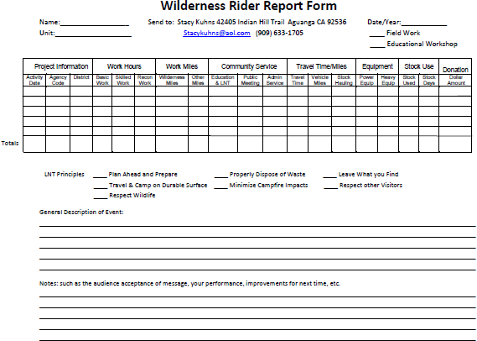Wilderness Rider Worksheet - use for individual WR projects. At the end of each year these reports are to be sent to the State Vice President –Education or Wilderness Rider Chair. A summary of your WR reports are to be giving to your Unit VHC to be included in your unit volunteer hours.

The Wilderness Rider worksheet is available for download at [http://www.bchcalifornia.org](http://www.bchcalifornia.org/) under the Wilderness Rider tab.

***Saddlebag Worksheet*** - use for unit, per project or individual member reporting. This goes to your VHC in your unit.

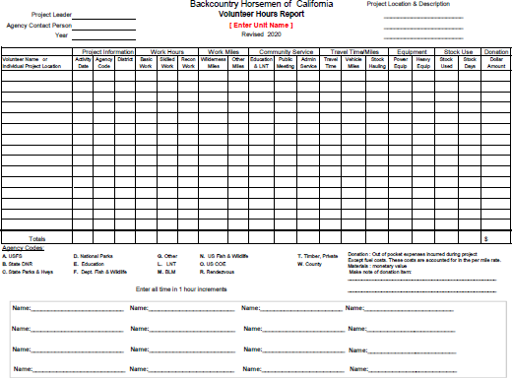The Saddlebag worksheet is available for download at [http://www.bchcalifornia.org](http://www.bchcalifornia.org/) under the Volunteer Hours tab.

Appendix B: Summary Worksheet

*BCHA Summary worksheet*

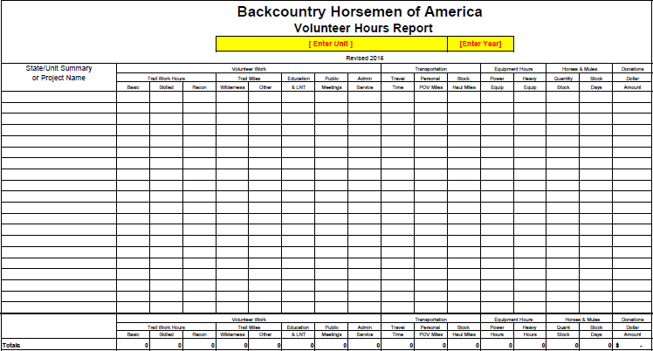

This worksheet is compiled by the VHC from each Unit from the information provided by project chairman and members and sent on to the State Vice President- Service as a summary by the March 1st reporting deadline.

The Volunteer hours reporting spreadsheet is available for download at [http://www.bchcalifornia.org](http://www.bchcalifornia.org/) under the Volunteer Hours tab

# BCHC Volunteer Hours Reporting Guide

## Totals Report

The Totals report is automatically compiled from the information copied to the summary worksheet from the project worksheets. For this to work properly, none of the formulae in the total column should be altered by the user. Only the State Vice President - Service can make changes of values. These change annually by BCHA midyear. At the end of each year your report will be updated and returned to you as your Unit Final Report.

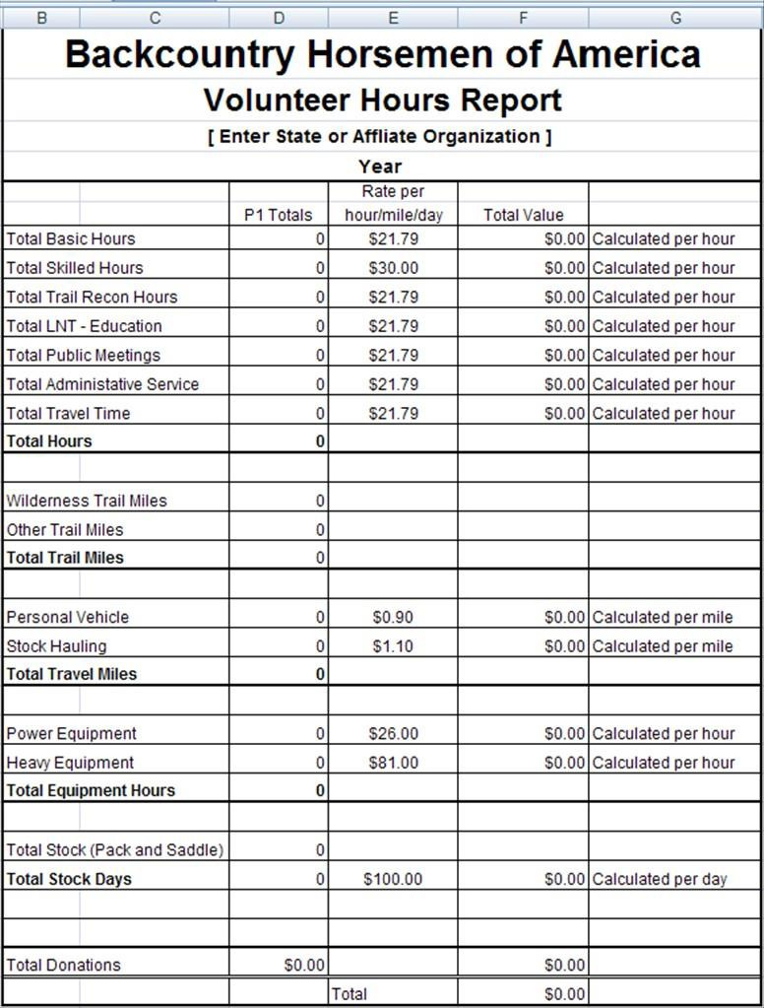

# Guide Appendix C: Microsoft Excel Tips

* + Naming worksheets
    - It is helpful for the VHC to rename project and/or summary worksheets as they are used to organize the report.
    - To rename a worksheet:
      * Highlight a worksheet template tab
      * Right click and select Rename
      * Enter the appropriate name
      * Click Enter
    - Renaming a sheet will not affect cell references (i.e. if you rename the SUMMARY SHEET, the data will still be referenced on the TOTALS worksheet).
  + Adding project worksheets:
    - The BCHC Volunteer Report template includes multiple projects worksheets. Project worksheets are provided to help the VHC organize the reporting for the Unit. Use as many worksheets as is appropriate for the Unit activities.
    - To add additional project worksheets:
      * Highlight PROJECT TEMPLATE tab
      * Right click and select Move or Copy
      * In the Before sheet box, highlight (move to end) or another worksheet
      * Check Create a copy
      * Click OK
      * Rename the new project sheet as appropriate
  + Adding rows to a worksheet:
    - It may be necessary for the VHC to add rows to a project or summary sheet to accommodate more participants or projects.
    - To insert row and maintain referential integrity for totals an summaries do one of the following:
      * To insert a single row, select either the whole row or a cell in the row above which you want to insert the new row.
      * To insert multiple rows, select the rows above which you want to insert rows.
      * On the Home tab, in the Cells group, click the arrow next to Insert, and then click Insert Sheet Rows.
  + Copying project totals to the Summary Sheet for unit reporting:
    - The VHC can complete a unit report by copying the totals from each project worksheet to the summary sheet. Totals will display in the totals row of the summary sheet as well as complete the report on the Totals Sheet.
      * Copy or enter the Project on the appropriate cell in Column A of the Summary Worksheet.
      * On the Project Worksheet, highlight the cells in the Totals row (Basic ➔ Donations)
      * Right click and select Copy
      * Go to the Summary Sheet
      * Highlight the cells in the appropriate row (Basic ➔ Donations)
      * Right click and select PASTE SPECIAL
      * In the dialog box, select Values
      * Click OK
      * Note: If you simply PASTE, you will get invalid reference errors [#REF!]. More advance users may want to click PASTE LINK. By pasting a link the row will update if the value on the project sheet are changed.

o For yearend reporting, the VHC should only send the summary to the state VP-Service .

* + Copying Unit totals to the summary sheet for state reporting:
    - The state VHC can copy the totals row from each Unit report into a state workbook in a similar fashion. Each row on the state summary sheet is a Unit row.
    - For yearend reporting to BCHA, the workbook is sent to the BCHA VHC.
  + Worksheet Protection
    - All of the worksheets have the formula rows protected to prevent inadvertent editing.
    - It may be necessary to edit the work hour or mileage rates on the Totals Sheet to display an accurate report. These rates can be edited in the unprotected cells in the column to the right of the Totals display.
    - In the event the VHC finds it necessary to edit protected rows, follow this procedure. No password is necessary.
      * To unprotect a worksheet:
        + On the Review tab, in the Changes group, click Unprotect Sheet.
      * To protect the worksheet:
        + On the Review tab, in the Changes group, click Protect Sheet.
        + Do not edit the selected checkboxes.
        + Click OK.
  + When editing is sometimes is necessary to undo mistakes.

The easiest method is to Click Undo  on the Quick Access Toolbar or use the keyboard shortcut Cntl+Z to undo your last action.

* + Printing
    - Project and summary worksheets are formatted to print landscape page width on 8½x11 paper. The size is reduced to fit.
    - The total sheet is formatted to print portrait on 8½x11 paper at full scale.